Simple channelizer properties
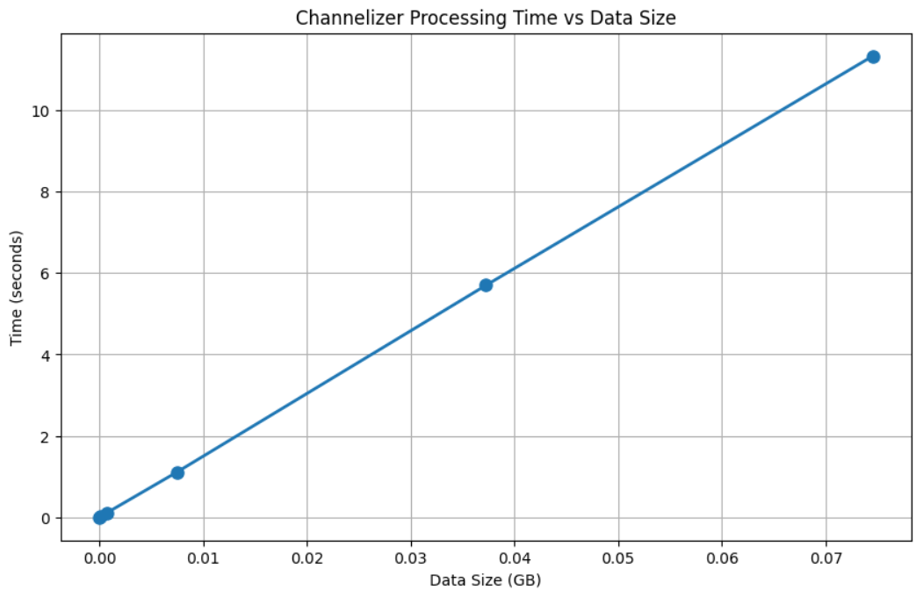

Computation complexity:
Each channel is going throw DDC (exponent multiplication) which corresponds to O(N), convolution with filter which corresponds to $O\left(L*N\right)$ and decimation (which in neglectable). So overall:
$$O\left(M*L*N\right)$$
Where M is number of channels, L is number of filter taps and N is number of samples.
Memory complexity:
for my vectorize implementation, the memory complexity is $O(M*N)$ which is derived from the phase matrix.
with the naïve way with using for loop on the number of channels, the memory complexity will be $O(N)$.

